**F.2 Mathematics Selection Test 2012-2013**

Name:______________________( ) Time allowed: 35 minutes

Class:_______________ Total marks: 30

Part 1 - (25 marks)

1. If  What is the value of x?

Answer:______________ (3 marks)

1.  Consider the following sequences:

|  |  |  |  |  |  |  |
| --- | --- | --- | --- | --- | --- | --- |
| A1 | A2 | A3 | A4 | A5 | A6 | …. |
| 1 | 5 | 11 | 19 | 29 | 41 | …. |

What is the value of A20?

Answer:______________(2 marks)

1. When the number is divided by 8, the remainder is 6. When it is divided by 7, the remainder is 3. When it is divided by 6, the remainder is 4. Find the smallest positive number that satisfies the above condition.

Answer:______________ (8 marks)

1. There are five identical yellow balls. You are required to put all of the balls into 3 baskets, one black, one white and one red. What is the possibility of having only one yellow in the black bucket?

Answer:______________ (6 marks)

1. 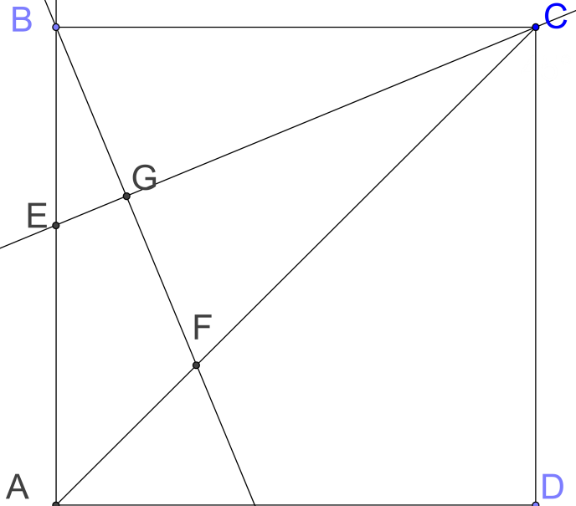Consider the square ABCD on the right. CG is the angle bisector of the angle BCF. Also, BF is perpendicular to CG. If the length of AB is 1 cm, find the length of AF.

Answer:______________ (6 marks)

Part 2 – (25 marks)

This question is set to determine a formula for 

We will first consider the following expression:

$${(n+1)}^{3}-n^{3}$$

1. What does the above expression equal to?

Answer:_______________________ (3 marks)

1. Express  in terms of (n-1)

Answer:________________________ (3 marks)

Now consider the following equations:



1. Fill in the blanks in the equations above. (4 marks)
2. Add up equations (1), (2), (3), (4)….. (n). What is the RHS? What is the LHS?

LHS =_________________________________________ (3 marks)

RHS =_________________________________________ (3 marks)

1. Evaluate  (9 marks)

End of paper